Adapter
(Structural)

Adapter design pattern is one of the structural design pattern and it is used so that two unrelated interfaces can work together. It is often used to make existing classes work with others without modifying their source code. The pattern involves creating an adapter class that bridges the gap between the interfaces, allowing them to communicate effectively. The adapter approach is very helpful when attempting to incorporate third-party libraries or legacy code into a new system.
One real-world example of the Adapter Design Pattern is a mobile charger. Mobile chargers act as adapters between the power socket and the mobile device, converting the voltage to a suitable level for charging the device. In software development, the Adapter Design Pattern follows the same concept by introducing an additional adapter class between an existing interface and a class that needs to work with it.

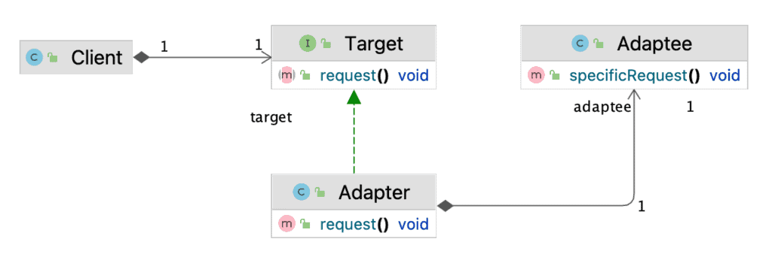
Different implementations of Adapter Design Pattern -:
There are two main approaches to implementing the Adapter Design Pattern: the class adapter pattern and the object adapter pattern. Both approaches produce the same result, but they use different techniques.
Class Adapter Pattern (Inheritance-based)
In a class adapter, the Adapter class extends both the Target interface and the Adaptee class. It inherits the behavior of the Adaptee and adapts it to match the Target interface. However, this approach requires multiple inheritance, which may not be supported in some programming languages.
Object Adapter Pattern (Composition-based)
In an object adapter, the Adapter class implements the Target interface and contains an instance of the Adaptee class. It delegates the calls from the Target interface to the Adaptee object, adapting its interface to match the Target interface. This approach uses composition instead of inheritance, making it more flexible and compatible with different programming languages.

Pros
Below are the pros of Adapter Design Pattern:
- By creating an adapter, you can reuse existing code without needing to modify it. This promotes code reuse and helps maintain a cleaner architecture.
- By separating the issues of interface adaptation, the adapter pattern frees classes to concentrate on their main duties without having to deal with adaptation code that clogs their logic.
- Because you can simply switch out multiple adapters to support different interfaces without altering the underlying system.
- By separating your system from particular implementations, adapters make it simpler to swap out or modify parts without compromising the functionality of other parts.

Cons
Below are the cons of Adapter Design Pattern:
- Introducing adapters can add a layer of complexity to your system. Having multiple adapters can make the code harder to navigate and understand.
- The additional layer of indirection may introduce slight performance overhead, especially if the adapter needs to perform complex transformations.
- If not managed properly, the use of adapters can lead to maintenance challenges. Keeping track of multiple adapters for various interfaces can become cumbersome.
- There’s a risk of overusing adapters for trivial changes, which can lead to unnecessary complexity. It’s critical to assess whether an adapter is actually required in a particular circumstance.
- Only two interfaces can be translated by adapters; if you need to adjust to more than one interface, you might need a lot of different adapters, which could make the design even more difficult.

Step 1
// Adaptee
class LegacyPrinter {
public void printDocument() {
System.out.println("Legacy Printer is printing a document.");
}
}

Step 2
// Target Interface
interface Printer {
void print();
}

Step 3
// Adapter
class PrinterAdapter implements Printer {
private LegacyPrinter legacyPrinter;

public PrinterAdapter() {
this.legacyPrinter = new LegacyPrinter();
}

@Override
public void print() {
legacyPrinter.printDocument();
}
}

Step 4
// Client Code
public class Client {
public static void clientCode(Printer printer) {
printer.print();
}

public static void main(String[] args) {
// Using the Adapter
PrinterAdapter adapter = new PrinterAdapter();
clientCode(adapter);
}
}
Resources:
https://www.geeksforgeeks.org/adapter-pattern/
https://medium.com/@akshatsharma0610/adapter-design-pattern-in-java-fa20d6df25b8
https://www.baeldung.com/java-adapter-pattern

